**APP International Class**

**Group G3**

Report of the Project



Kuiyu Ding

Shola A. Olayemi

Sudharshan A V

Bello Nuhu

Fahadh Mohamed

14 December 2022

1.Introduction

When people are exercising, they always want to know the environmental quality index of the outside world to know whether the environment is suitable for exercise. Therefore, we put sensors and microcontrollers at the entrances and exits of places where people often exercise, such as parks or forests, to detect air quality, such as temperature, Moderation, CO2 concentration, pm2.5 concentration and ambient sound intensity. So the purpose of this project is, by connecting different environmental sensors (sound, temperature and humidity, co2 concentration and dust) to the Tiva board, this detection system can be turned on by playing an audio with a certain sound intensity and a specific frequency by being close to the sensor , and record and analyze the stored data on the main board, display the sound intensity and quality and the overall air quality through the local playback screen, and athletes can use their smartphones to receive other specific temperature, humidity, co2 concentration, pm2. 5 Concentration and other data.

Environment sense process as shown in Figure 1.1 is described below:

The microphone is used to detect the intensity of ambient noise and specify the audio key.

When the microphone receives the sound signal, it will perform a preliminary signal power check to save battery power; when the sound signal strength is greater than the minimum threshold value set, the band-pass filter is activated.

When the audio key successfully passes through two band-pass filters of specified frequency, the main board will process the data of each sensor received by tivaboard. tivaboard starts to analyze various environmental indexes to determine the quality of the environment and whether it is suitable for running sports. At the same time, the main board sends part of the data (sound intensity, quality, whether the environment is suitable for outdoor sports overall assessment) to Oled, and all parameters and analysis results Send to mobile phone via bluetooth.  
  
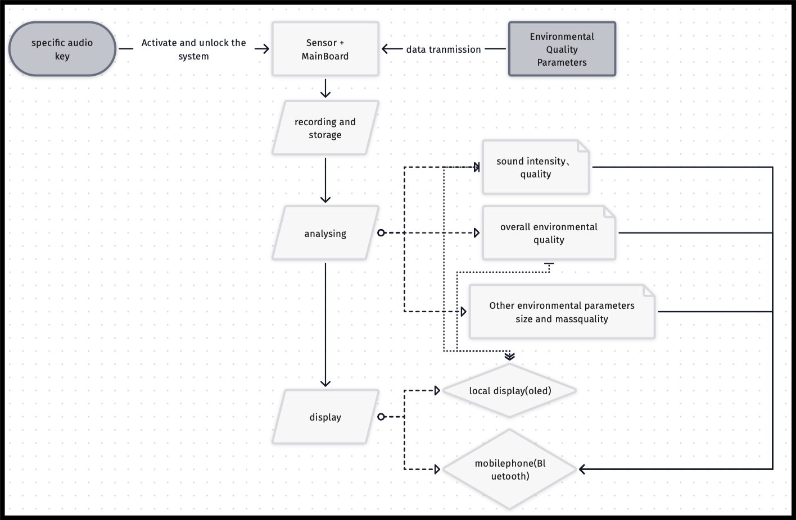

Figure1.1.Flow chart for environment dectection system

2.Project Overview

The design mechanism of this solution is presented in Figure 2.1

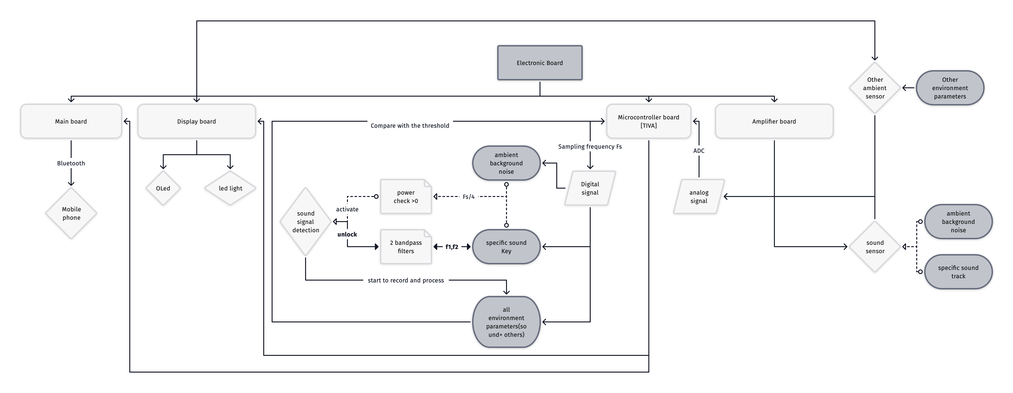

Figure 2.1. Flow Chart

3.electronic board description (need to add in):

Battery consumption, memory, etc...

**Energy Conservation**

* The product consumes 456mw of power
* The product is expected to run for 13 hours a day.
* Consequently, the power consumption is 6000mwh.
* Therefore, energy consumed in 1 year = 6000 x 365 = 2,190,000mwh
* i.e. 2.19Kwh
* This equivalent to 0.0009 Metric Tons of CO2 = 1 pound of coal burned = 0.001 acres of US forest in 1 year.

**Battery Autonomy**

Battery Lithium-ION

EEMB 3.7V 2000mAh

103454

Battery Lithium-ION

Rechargeable with connector

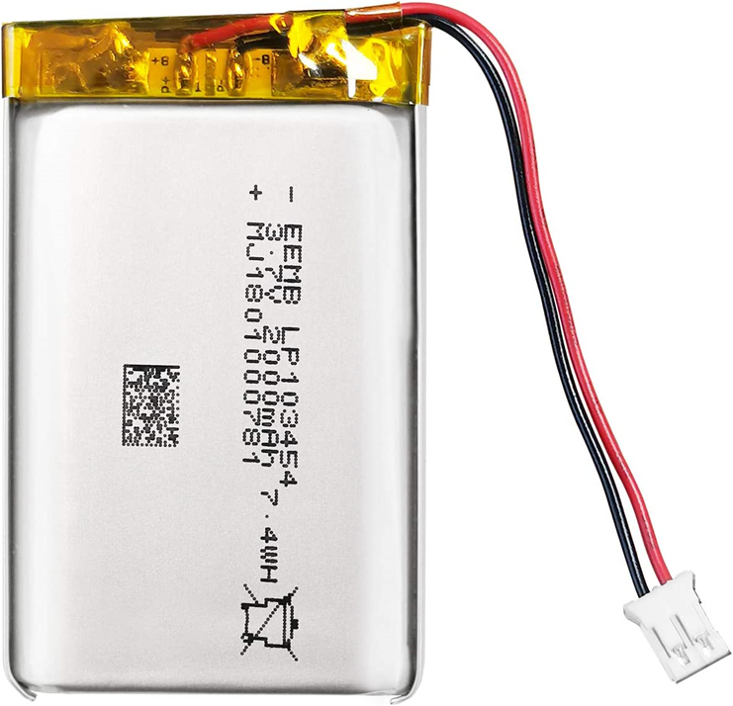

**Storage & Application**

No leaks, excellent economic performance and long service life.

**PCM protection function:**

over charge, over discharge, over current, short circuit protection,

over temperature protection.

Keep cells in 40-60% state of charge during long-term storage.

Recommend charging the battery every 3 months

after receiving the battery and keeping the voltage 3.7-4.0V.

4.sound Signal Detection

4.1 Signal power Detectio（Trigger）

Before detecting the signal power, we set the working time of the system (clock) as 9: 00am to 17:00pm,

This means that between 17:00pm and 9: 00am, the system is default off，

Because only few people want to exercise when outside is dark.

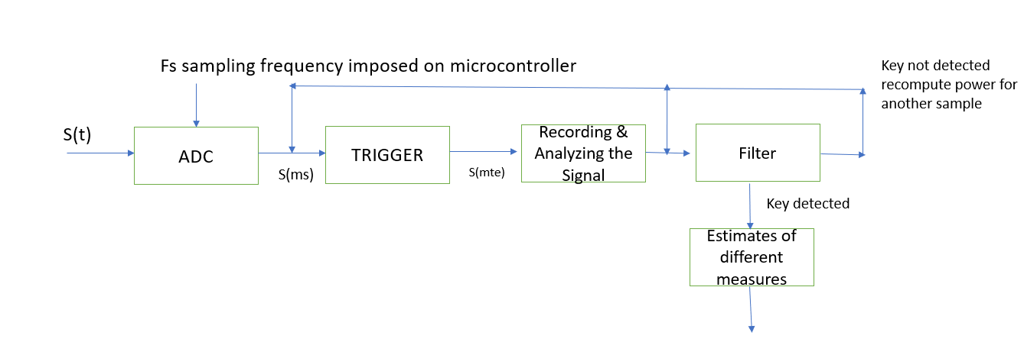

And this part of the ambient parameters detection system, the sound emitted by a person who plays a certain frequency of music. Before sampling, Filters and amplifier will be used to process the sound signal. The microcontroller used was TM4C123GXL. And the amplifier board has already been given. So, through power detection and built-in filters, the system can determine whether the sound signal can be considered as activation key and security key.

The signal after the amplifier can be read by microcontroller. In TIVA board, the Analog-to-Digital Converter can be used by calling the built-in function analogRead(). millis() function can be used to calculate the time spent in signal sampling, A suitable delay can be used between each sampling to control the sampling frequency.

Once the digital signals have been obtained, operations can be performed on these signals. The first operation performed by the board is to check for sound signal power. This step ensures that unnecessary power is never wasted on filters if the environmental sound power is not high enough to be classified as a quite threshold. The formula shown in Formula 4.1, and it will be implemented in C language for microcontroller to do the judgement.

Before calculating the environmental noise intensity, in order to reduce the amount of calculation and system power consumption, we reduce the sampling frequency to 1/4 of the sampling frequency of the microphone.

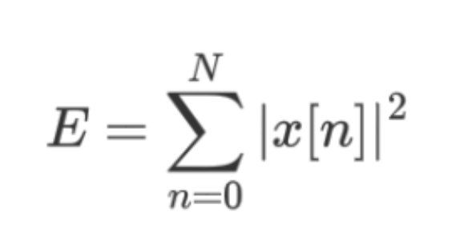

Figure 4.1. The Energy Formula of Discrete Time Signal

4.2 signal frequency dection（security key）

If the power of the signal crosses the defined threshold value for a quiet, the signal is then forwarded to bandpass filter.Before put signal into filter, we need fast Fourier transformation （FFT） to transform the digital signal into frequency domain and then viewed the spectrum of the signals.The Band Pass filter is employed to recognize the frequency band of the signal. And a sound signal can be regarded as composed of at least 2 frequencies

so,By setting 2 frequencies of the passband to be near the audio key frequencies, the signal that audio key at a specific frequency can be got. If the signal passes two frequencies band-pass filters, the system will start to record data from all the sensors and start to process the data.

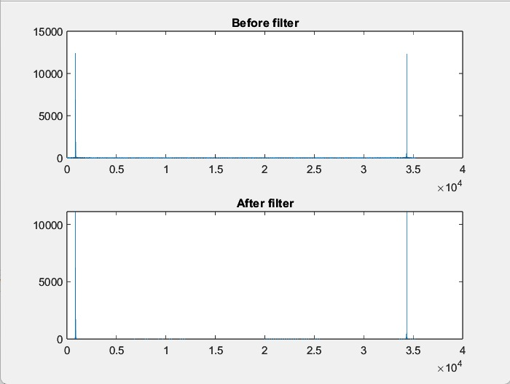

Figure 4.2 shows the spectrogram of the signal before and after band-pass filter.

5.Signal quality analysis

5.1 noise level detection

After the audio key pass the bandpass filter,

Sound power check will be performed again to confirm that there is a signal in the passband. The signal will be sent to the main board to display the level of sound and other parameters.

Here we use decibels（dB) to judge the noise level, through formula dB = 20*log(A/B), A represents the actual environmental sound intensity, B is the sound intensity of the environment in a quiet state;

Sound level:  
 0-40 db low; led green

40-80 db middle; led blue

80～120dB noisy; led light red

Display the sound level on the Oled。

4.2 other Signal quality analysis

Thresholds of the following environmental parameters:

Since temperature is a more important parameter to the pm2.5 in our final decision, we assigned numerical values of 3.5 and 2.5 respectively as constants in calculating the weighted average of each of the ranges of both parameters.

The final decision is represented as follows:

0<=final output<=50: unsuitable

51<=final output<=70: fairly suitable

71<=final output<=100: suitable

For the temperature (importance index: 3.5)

RANGE: -4°C - 30°C

-4 - -1: Bad Bad: 0=0%

0°C -6°C: Fair Fair: 2.5 =50%

7°C – 15°C: Ideal Ideal: 5=100%

16°C – 22°C: Fair

23°C – 30°C: Bad

PM2.5 (importance index: 2.5)

Range: 0 – 150 Unhealthy: 0=0%

0 – 12: Good: 1=33.3%

12.1 – 35.5: Moderate Moderate: 3=60%

35.5 – 55.4: Unhealthy for Sensitive people Good: 5=100%

55.5 -150.4: Unhealthy

Temperature and Humidity :

The final computation of the temperature and pm2.5 in percentage determines the decision as to whether it is conductive to jog or not. We connected the temperature and humidity sensor in external board, and we tested in energia.

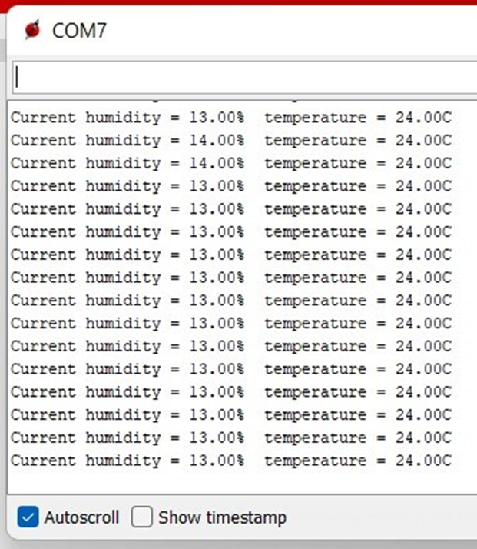

Filtered signal :

We got the bandpass filter coefficients from matlab for 400 Hz by using fdatool.

And we added these coefficients in energia to filter the signal. We compared our original signal power and filtered signal power. And we tested power and filtered power with 400 Hz. The filtered power is close to original signal's power. It shows the signal is filtered. We also tried with 1000 Hz, it doesn’t filter the signal.

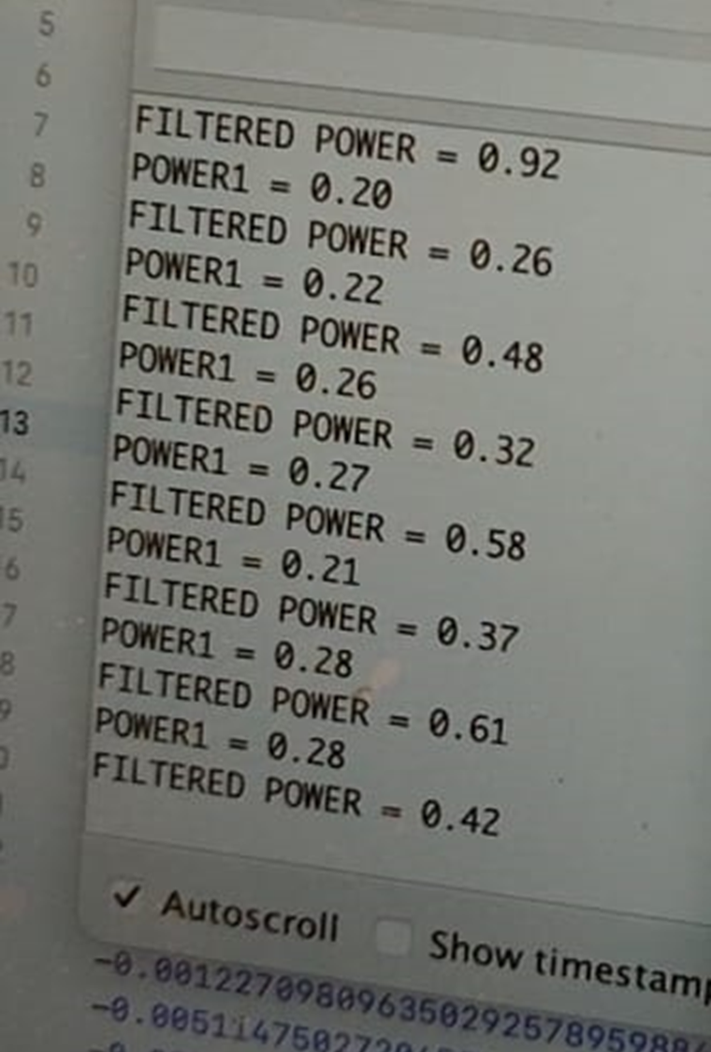

6.Display the data

The sensor result is sent to mobile phone via bluetooth.

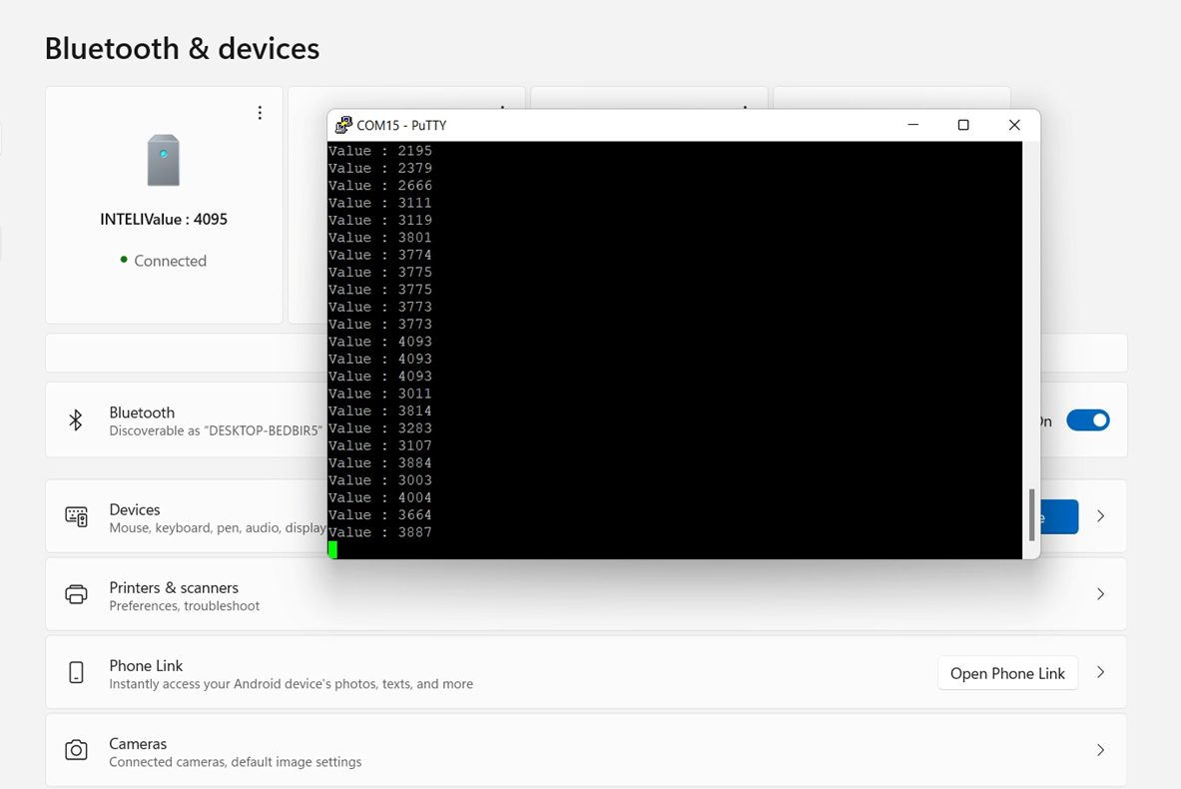

Use Oled display the following message:

“Sound level: __B

Sound quality: low/middle/noisy

unsuitable/fairly suitable/ suitable for exercising!”;

Use led light display green/blue/red when the sound quality is low/middle/noisy;

Code on tiva , and receive the environment data from mobilephone via bluetooth:

Sound level: _dB，low/middle/noisy;

Temperature： __℃， Bad/Fair/Ideal；

HUmity: __

Co2: __, Good/Moderate/Unhealthy for Sensitive people/Unhealthy

PM2.5:__, Good/Moderate/Unhealthy for Sensitive people/Unhealthy

Receive a message like these every 10 seconds

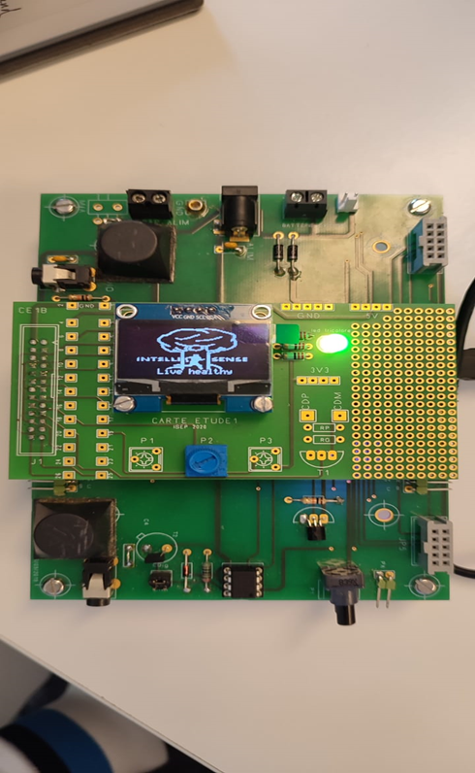

**Future Planning**

* Collaborate or sell the product to a fitness app development company
* Adaptation of the product to various environments.